**ERP SOLUTIONS INC.**

By

**Ujjwal Kumar Chowdary Konka**

M.Sc. Data Warehousing and Data Mining, University of Greenwich, 2012

**Bilal Bailey**

B.S., Northern Illinois University, 2000

**Chengpeng Li**

B.S., University of Donghua, Shanghai, 2009

**VSN Surendra Koppuravuri**

B.Tech, KL University, 2010

GRADUATECAPSTONE SEMINAR PROJECT

Submitted in partial fulfillment of the requirements

For the Degree of Master of Science,

With a Major in Computer Science



Governors State University

University Park, IL 60484

2016

ABSTRACT

**Company: ERP Solutions Inc.**

The objective of this project is to create an online enterprise resource planning application which allows various manufacturing companies to manage their day to day operations and plan resources accordingly. This is important part of business systems which supports the concept of continuous improvement by giving organizations the resources needed to reduce waste.

The problem which most manufacturing facilities encounter is poor communication between various function such as production and master production schedulers. For example, on day shift the production team is scheduled to produce two thousand xy widgets and after completing the order then change over to xyz widgets. What if day shift production encounter significant downtime and run behind schedule? This places production behind schedule and can also influence the way raw material is ordered. Therefore, the goal of this project is to create an application which can be leverage by all functions to make decisions as well as identify performance gaps.

The enterprise resource planning software will be a newly implemented software replacing a paper system used to reconcile production resources and cost at the end of each shift. The system is scheduled to be available for use by production supervisors by April 2016.

Table of Content

***1*** ***Project Description*** 1

1.1 Competitive Information 1

1.2 Relationship to Other Applications/Projects 1

1.3 Assumptions and Dependencies 1

1.4 Future Enhancements 2

1.5 Definitions and Acronyms 3

***2*** ***Project Technical Description*** 3

2.1 Application Architecture 3

2.2 Application Information flows 8

2.3 Interactions with other Projects (if Any) 9

2.4 Interactions with other Applications 9

2.5 Capabilities 9

2.6 Risk Assessment and Management 9

***3*** ***Project Requirements*** 9

3.1 Identification of Requirements 9

3.2 Operations, Administration, Maintenance and Provisioning (OAM&P) 16

3.3 Security and Fraud Prevention 16

3.4 Release and Transition Plan 16

***4*** ***Project Design Description*** 16

***5*** ***Internal/external Interface Impacts and Specification*** 22

***6*** ***Design Units Impacts*** 23

6.1 Functional Area A/Design Unit A 23

***6.1.1*** ***Functional Overview*** 23

***6.1.2*** ***Impacts*** 23

***6.1.3*** ***Requirements*** 23

***7*** ***Open Issues*** 23

***8*** ***Acknowledgements*** 23

***9*** ***References*** 24

# ***Project Description***

The objective is to design and develop an application which will allow a production supervisor to input data at the end of the shift and review shift performance.  The results should be captured in a database, so that other business functions can review the data to make business decisions.  The data that needs to be captured in this application is as followed... labor cost, cases produced, number of hours scheduled to work and actual hours worked, and downtime.

## Competitive Information

Considering the significant change in the market for Enterprise Resource Planning (ERP) systems during the last years, most large companies had enough money to invest in ERP solutions in their business but not the small and medium-sized enterprises. It is obvious that companies can receive a benefit from keeping using the ERP systems. The challenge for our team is to design an affordable ERP system for small enterprise.

## Relationship to Other Applications/Projects

From the software interface view as followings, our ERP system is totally different from other projects or other applications. However in our project there is a calculator which you can find in other applications as well.

## Assumptions and Dependencies

* We may add new functions to minimize operational in using ERP systems.
* We use MySQL Workbench creating three tables to implement each function.

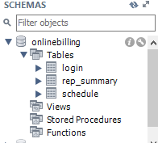

* We changed the layout of ShiftReport to make it more comprehensible.

Old Layout Design

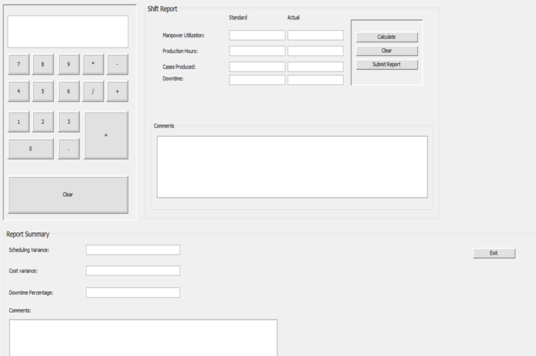

New Layout Design

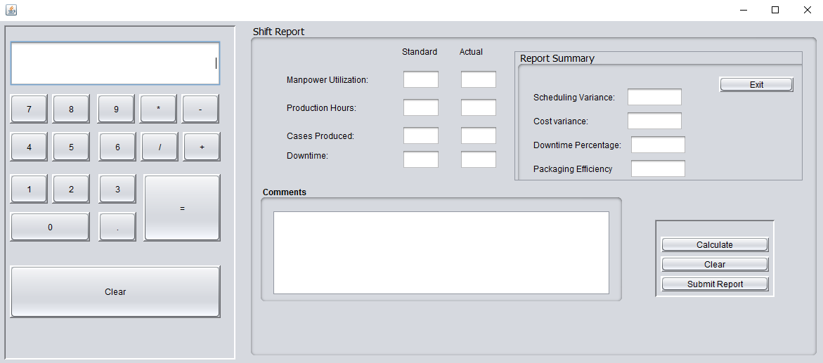

## Future Enhancements

Possible future enhancements is to create a mobile applications on various platforms such as Android, IOS, and Windows and customized user interfaces (UI) for other business functions such as maintenance, shipping, receiving, sales and human resources. Also, to integrate scientific calculator and the ability to run reports from the application UI.

## Definitions and Acronyms

API- application programmer interface

ERP- enterprise resource planning

GUI- graphical user interface

JDK- java development kits

RDBMS- relational database management system

SQL- structured query language

UI- user interface

JDBC-java database controls

# ***Project Technical Description***

In this project we designed a desktop application that can be utilize by a floor supervisor to track key performance measures. The user (floor supervisor) will be asked to provide a username and password to log into the application. Then the system will present the user with three options to choose from which are today’s schedule, shift report, or exit. If the user select today’s schedule he or she will be directed to a spreadsheet with the production schedule information. Else if, the user select shift report he or she will be directed to a form that requires user input based on some key performance measures. This should calculate the following scheduling variance, cost variance, downtime percentage and packaging efficiency. Lastly in the event the user select exit, then the program should simply close.

## Application Architecture

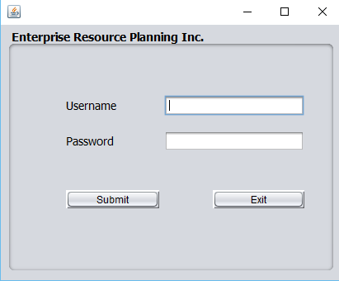

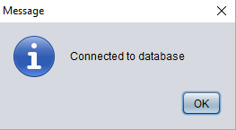

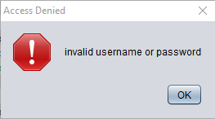

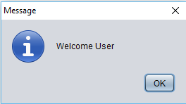

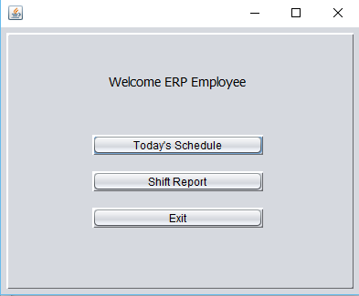

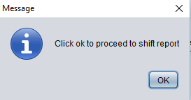



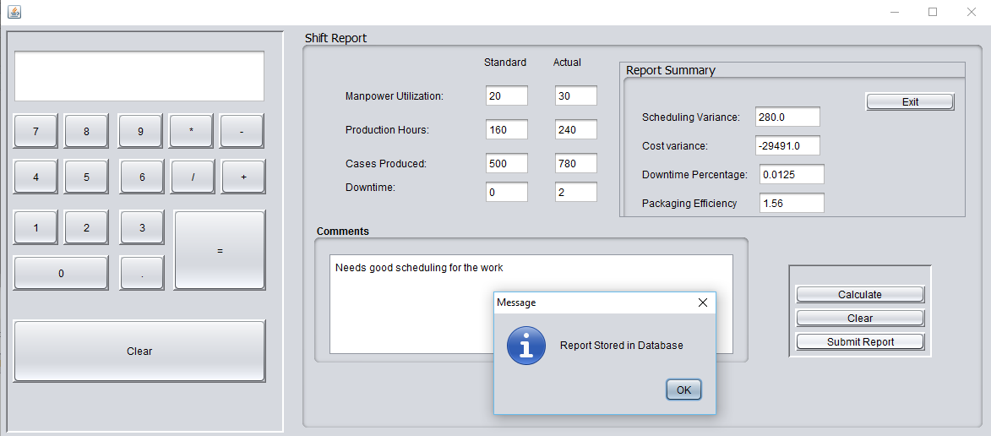

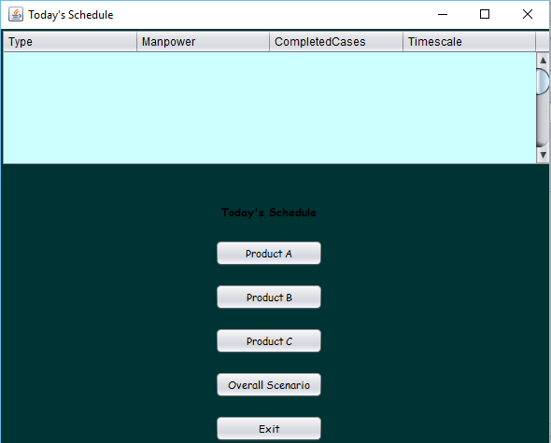



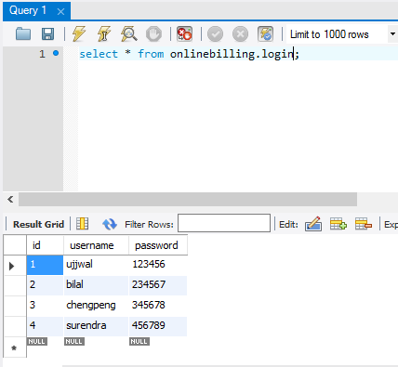

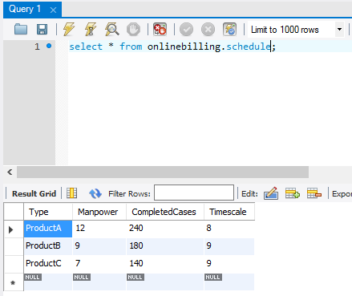

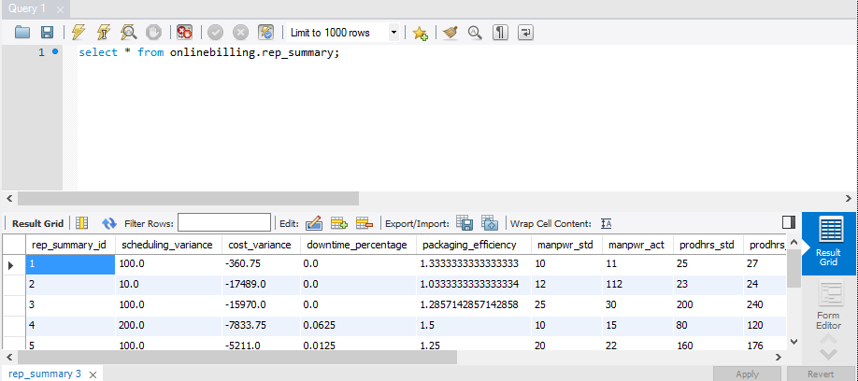

## Application Information flows

**Step 1:** Login to the ERP Software using the username and password provided to the user by the Admin.

**Step 2:** As soon as the user connects to the database, he/she gets an acknowledgement on the Pop up window saying

that he/she is "Connected to Database".

**Step 3:** If the user fails to connect to the Database then he/she will get an acknowledgement on the Pop up window

saying that its "invalid username or password".

**Step 4:** After the successful connection "Welcome User" is Displayed with OK button.

**Step 5:** When the user clicks on OK button then he/she is directed to "Welcome ERP Employee" Screen. Here there

are three choices for the user. Choice three is to exit out of the application

1. Today's Schedule
2. Shift Report
3. Exit

**Step 6:** When the user clicks on "Today's Schedule Button" then he is directed to the today's schedule module.

**Step 7:** When the user clicks on "Shift Report" then he is directed to the Shift Report module.

**Step 8:** If the user wants to terminate out of the module then he/she can simply click on "Exit" button.

**Step 9:** Today's Schedule Button displays the what type of the product work is done, how much Manpower was used,

how many cases were completed, how much time was elapsed. You can also view individual Products

information by clicking on respective Product buttons (Product A, Product B, Product C). Also you can view

Overall Scenario by clicking on the "Overall Scenario" Button. If the user wants to exit then he can click on

"Exit" button.

**Step 10:** Shift report button displays the module which contains an on screen Calculator.

1. Manpower Utilization, Production Hours, Cases Produced, Downtime---> These are noted as Standard Schedule and also Actual work done in real time.
2. Comments box is there for the user to write down the comments to store in database.
3. After entering the data in the Standard and Actual fields of Manpower Utilization, Production Hours, Cases Produced and Downtime, Comments Box then the User can click on "Calculate" to calculate the "Scheduling Variance", "Cost Variance", "Downtime Percentage", "Packaging Efficiency".
4. All the calculated values are stored in to the database by clicking on "Submit Report" button.
5. There is "Clear" button if you want to clear all the fields and start again.

**Database:**

1. We have created three tables for the application namely, login, rep_summary, schedule.
2. "login" table stores the id, username and password fields.
3. "rep_summary table stores the rep_summary_id, scheduling_variance, cost_variance, downtime_percentage, packaging_efficiency, manpwr_std, manpwr_act, prodhrs_std, prodhrs_act, casesprod_std, casesprod_act, dwnt_std, dwnt_act, comments fields.
4. "schedule" table stores Type, Manpower, CompletedCases, Timescale fields.

## Interactions with other Projects (if Any)

## Interactions with other Applications

For now it's just a simple desktop application, so it doesn't interact with any other applications. But in future versions it might interact with API's, CRM etc depending on the next level of the application.

## Capabilities

The user can input the data by logging in the application with his login credentials to proceed in order to run the application and the administrator can delete or modify any kind of information in the database with his login credentials. Also he can add or delete the number of users who were working on the application. The application provides different sections to proceed to get final output result.

## Risk Assessment and Management

|  |  |
| --- | --- |
| POTENTIAL RISK | ACTION TO MANAGE RISK |
| The database may run out space | Upgrade the database |
| Database may crash | Maintain regular backups and maintain duplex system(production and development database) |
| SQL Injection | To overcome the problems of SQL injection we have used better coding by making use of Prepared statements |

# ***Project Requirements***

## Identification of Requirements

This section provides a brief explanation of the use of named and enumerated requirements to identify and number requirements. For each requirement, please use the following SMART criteria as guidelines (<https://en.wikipedia.org/wiki/SMART_criteria>):

* **S**pecific – target a specific area for improvement.
* **M**easurable – quantify or at least suggest an indicator of progress.
* **A**chievable – specify what will be accomplished
* **R**ealistic – state what results can realistically be achieved, given available resources.
* **T**ime-related – specify when the result(s) can be achieved.

**<ERP-GSU_SP2016-UI_Login-001>**

**A variable lblUsername used to describe the label Username.**

Implementation:

**<ERP-GSU_SP2016-UI_Login-002>**

**A variable lblPassword used to describe the label Password.**

Implementation:

**<ERP-GSU_SP2016-UI_Login-003>**

**A variable txtUsername used to describe a text box where the user inputs his or her username.**

Implementation:

**<ERP-GSU_SP2016-UI_Login-004>**

**A variable txtPassword used to describe a text box where the user inputs his or her password.**

Implementation:

**<ERP-GSU_SP2016-UI_Login-005>**

**A variable btnSubmit that represent an action button which verifies the username and password against a database table.**

Implementation:

**<ERP-GSU_SP2016-UI_Login-006>**

**A variable btnExit that represent an action button which allows the user to exit the application.**

Implementation:

**<ERP-GSU_SP2016-UI_Login-007>**

**A panel box jPanel with the title of the company embedded.**

Implementation:

**<ERP-GSU_SP2016-UI_Login-008>**

**A Message shows successful connection to the Database.**

Implementation:

**<ERP-GSU_SP2016-UI_Login-009>**

**A variable JOptionWelcome used to displays a message "Welcome User" after user log into application.**

Implementation:

**<ERP-GSU_SP2016-UI_Login-010>**

**A variable JOptionDenied used to displays a message "invalid username or password", "Access Denied" in the event the user uses an invalid password or username.**

Implementation:

**<ERP-GSU_SP2016-UI_Login-011>**

**AnSQLException exception handler for login form SQL connection.**

Implementation:

**<ERP-GSU_SP2016-UI_Login-012>**

**A developer must import java packages like javax.swing.*, java.sql.*, and java.awt.HeadlessException.**

Implementation:

**<ERP-GSU_SP2016-UI_Login-013>**

**Use of Prepared Statements to avoid SQL Injection.**

Implementation:

**<ERP-GSU_SP2016-UI_Login-014>**

**Mysql-connector-java-5.1.38 is used to connect to DB.**

Implementation:

**<ERP-GSU_SP2016-UI_Welcome-015>**

**A jLabel1 box with the message "Welcome ERP Employee" embedded in it.**

Implementation:

**<ERP-GSU_SP2016-UI_Welcome-016>**

**A button for Today's Schedule named btnProduction that directs the user to the daily production schedule.**

Implementation:

**<ERP-GSU_SP2016-UI_Welcome-017>**

**A button for Shift Report named btnShiftreport that directs the user to the shift report form.**

Implementation:

**<ERP-GSU_SP2016-UI_Welcome-018>**

**A button for Exit named btnExit that allows the user to exit the application.**

Implementation:

**<ERP-GSU_SP2016-UI_Welcome-019>**

**A message box with variable "JOptionProduction" for confirming the access to Today's schedule.**

Implementation:

**<ERP-GSU_SP2016-UI_Welcome-020>**

**A message box with variable "JOptionShiftreport" for confirming the access to Shift Report.**

Implementation:

**<ERP-GSU_SP2016-UI_Welcome-021>**

**A developer must import java package named javax.swing.**

Implementation:

**<ERP-GSU_SP2016-UI_Shift_Report-022>**

**jPanel1 is used to embed an online calculator for mathematical operations.**

Implementation:

**<ERP-GSU_SP2016-UI_Shift_Report-023>**

**A variable txtCalculatorWindow used describe the Text field used for calculations.**

Implementation:

**<ERP-GSU_SP2016-UI_Shift_Report-024>**

**A button named btnZero used to display value Zero.**

Implementation:

**<ERP-GSU_SP2016-UI_Shift_Report-025>**

**A button named btnOne used to display value One.**

Implementation:

**<ERP-GSU_SP2016-UI_Shift_Report-026>**

**A button named btnTwo used to display value Two.**

Implementation:

**<ERP-GSU_SP2016-UI_Shift_Report-027>**

**A button named btnThree used to display value Three.**

Implementation:

**<ERP-GSU_SP2016-UI_Shift_Report-028>**

**A button named btnFour used to display value Four.**

Implementation:

**<ERP-GSU_SP2016-UI_Shift_Report-029>**

**A button named btnFive used to display value Five.**

Implementation:

**<ERP-GSU_SP2016-UI_Shift_Report-030>**

**A button named btnSix used to display value Six.**

Implementation:

**<ERP-GSU_SP2016-UI_Shift_Report-031>**

**A button named btnSeven used to display value Seven.**

Implementation:

**<ERP-GSU_SP2016-UI_Shift_Report-032>**

**A button named btnEight used to display value Eight.**

Implementation:

**<ERP-GSU_SP2016-UI_Shift_Report-033>**

**A button named btnNine used to display value Nine.**

Implementation:

**<ERP-GSU_SP2016-UI_Shift_Report-034>**

**A button named btnDecimal used for decimal points.**

Implementation:

**<ERP-GSU_SP2016-UI_Shift_Report-035>**

**A button named btnDivide used for dividing two numbers.**

Implementation:

**<ERP-GSU_SP2016-UI_Shift_Report-036>**

**A button named btnMultiply used for multiplying two numbers.**

Implementation:

**<ERP-GSU_SP2016-UI_Shift_Report-037>**

**A button named btnPlus used to add two numbers.**

Implementation:

**<ERP-GSU_SP2016-UI_Shift_Report-038>**

**A button named btnMinus used to subtract two numbers.**

Implementation:

**<ERP-GSU_SP2016-UI_Shift_Report-039>**

**A button named btnEqual used to add two numbers.**

Implementation:

**<ERP-GSU_SP2016-UI_Shift_Report-040>**

**A button named btnClearCal used to clear the calculations.**

Implementation:

**<ERP-GSU_SP2016-UI_Shift_Report-041>**

**jPanel2 is used to embed Shift Report Calculations.**

Implementation:

**<ERP-GSU_SP2016-UI_Shift_Report-042>**

**jLabel1 used to Display Standard.**

Implementation:

**<ERP-GSU_SP2016-UI_Shift_Report-043>**

**jLabel2 used to Display Actual.**

Implementation:

**<ERP-GSU_SP2016-UI_Shift_Report-044>**

**A label named lblmanpower used for man power utilization.**

Implementation:

**<ERP-GSU_SP2016-UI_Shift_Report-045>**

**A Text field named txtmanpowerStd used to input Man Power according to the Schedule used.**

Implementation:

**<ERP-GSU_SP2016-UI_Shift_Report-046>**

**A Text field named txtmanpowerAct used to input Man Power used in excess or less apart from the Schedule.**

Implementation:

**<ERP-GSU_SP2016-UI_Shift_Report-047>**

**A label named lblproductionHrs used for Production Hours.**

Implementation:

**<ERP-GSU_SP2016-UI_Shift_Report-048>**

**A Text field named txt_lineTimeStd used to input Production Hours according to the Schedule planned.**

Implementation:

**<ERP-GSU_SP2016-UI_Shift_Report-049>**

**A Text field named txt_lineTimeAct used to input Production Hours according to the Schedule planned.**

Implementation:

**<ERP-GSU_SP2016-UI_Shift_Report-050>**

**A label named lblcasesProduced used for cases produced.**

Implementation:

**<ERP-GSU_SP2016-UI_Shift_Report-051>**

**A Text field named txt_numCaseStd used to input Cases produced by the staff according to the Schedule planned.**

Implementation:

**<ERP-GSU_SP2016-UI_Shift_Report-052>**

**A Text field named txt_numCaseAct used to input Cases produced by staff after an increase or decrease in the staff according to the actual schedule.**

Implementation:

**<ERP-GSU_SP2016-UI_Shift_Report-053>**

**A label named lbldownTime used for Downtime.**

Implementation:

**<ERP-GSU_SP2016-UI_Shift_Report-054>**

**A Text field named txt_downtimeStd used to input the standard downtime according to the Standard schedule.**

Implementation:

**<ERP-GSU_SP2016-UI_Shift_Report-055>**

**A Text field named txt_downtimeAct used to input the Actual downtime according to the Actual schedule.**

Implementation:

**<ERP-GSU_SP2016-UI_Shift_Report-056>**

**A Panel Box named jPanel5 is used to embed the buttons Calculate, Clear and Submit.**

Implementation:

**<ERP-GSU_SP2016-UI_Shift_Report-057>**

**A button named btnCalculate is used to calculate the inputs of the shift report.**

Implementation:

**<ERP-GSU_SP2016-UI_Shift_Report-058>**

**A button named btnClear is used to clear all the inputs from the Text fields.**

Implementation:

**<ERP-GSU_SP2016-UI_Shift_Report-059>**

**A button named btnSubmit is used to Submit the form data of shift report and report summary to the database.**

Implementation:

**<ERP-GSU_SP2016-UI_Shift_Report-060>**

**jPanel3 is used to embed comments text area into it.**

Implementation:

**<ERP-GSU_SP2016-UI_Shift_Report-061>**

**A text area named txtAreaComments used as a user input for user comments.**

Implementation:

**<ERP-GSU_SP2016-UI_Shift_Report-062>**

**A Panel Box named jPanel4 is used to embed the Report Summary contents into it.**

Implementation:

**<ERP-GSU_SP2016-UI_Shift_Report-063>**

**A Panel Box named jPanel7 is used to embed Scheduling Variance, Cost Variance, Downtime Percentage and Packaging Efficiency.**

Implementation:

**<ERP-GSU_SP2016-UI_Shift_Report-064>**

**A label named jLabel3 is used to Display Scheduling Variance.**

Implementation:

**<ERP-GSU_SP2016-UI_Shift_Report-065>**

**A Text field named txtschedulingVariance is used to display the calculated Scheduling Variance from the shift report.**

Implementation:

**<ERP-GSU_SP2016-UI_Shift_Report-066>**

**A label named jLabel4 is used to Display Cost Variance.**

Implementation:

**<ERP-GSU_SP2016-UI_Shift_Report-067>**

**A Text field named txtcostVariance is used to display the calculated Cost Variance from the shift report.**

Implementation:

**<ERP-GSU_SP2016-UI_Shift_Report-068>**

**A label named jLabel5 is used to Display Downtime Percentage.**

Implementation:

**<ERP-GSU_SP2016-UI_Shift_Report-069>**

**A Text field named txtpercentDowntime is used to display the calculated Downtime Percentage from the shift report.**

Implementation:

**<ERP-GSU_SP2016-UI_Shift_Report-070>**

**A label named lblpackagingEff is used to Display Pacakaging Efficiency.**

Implementation:

**<ERP-GSU_SP2016-UI_Shift_Report-071>**

**A Text field named txtpackagingEff is used to display the calculated Packaging Efficiency from the shift report.**

Implementation:

**<ERP-GSU_SP2016-UI_Shift_Report-072>**

**A Panel box named jPanel6 is used to embed Exit button in it.**

Implementation:

**<ERP-GSU_SP2016-UI_Shift_Report-073>**

**A button named btnExit is used to Exit the application.**

Implementation:

**<ERP-GSU_SP2016-UI_Shift_Report-074>**

**A label named jLabel6 is used to display Comments.**

Implementation:

**<ERP-GSU_SP2016-UI_Shift_Report-075>**

**A text area named txtresultComment is used to Display the comments from the Shift Report.**

Implementation:

**<ERP-GSU_SP2016-Database-076>**

**A database with the name onlinebilling is created in mysql workbench.**

Implementation:

**<ERP-GSU_SP2016-Database-077>**

**Utf8_general_ci collation is used.**

Implementation:

**<ERP-GSU_SP2016-Database-078>**

**Version 10 is Used.**

Implementation:

**<ERP-GSU_SP2016-Database-079>**

**InnoDB is used.**

Implementation:

**<ERP-GSU_SP2016-Database-080>**

**Utf8 is used.**

Implementation:

**<ERP-GSU_SP2016-Database-081>**

**Three tables are created. The tables are login, schedule and rep_summary.**

Implementation:

**<ERP-GSU_SP2016-Database-082>**

**A table named login with attributes id, username and password with primary key on id is created.**

Implementation:

**<ERP-GSU_SP2016-Database-083>**

**A table named rep_summary with attributes rep_summary_id, scheduling_variance, cost_variance, downtime_percentage, packaging_efficiency, manpwr_std, manpwr_act, prodhrs_std, prodhrs_act, casesprod_std, casesprod_act, dwnt_std, dwnt_act, comments with primary key on rep_summary_id is created.**

Implementation:

**<ERP-GSU_SP2016-Database-084>**

**A table named schedule with attributes like Type, Manpower, CompletedCases, and TimeScale is**

**created.**

Implementation:

**<ERP-GSU_SP2016-UI_Schedule-085>**

**A label named ScheduleLab shows the title of Today's Schedule.**

Implementation:

**<ERP-GSU_SP2016-UI_Schedule-086>**

**A button named btnProductA that displays the information of product A.**

Implementation:

**<ERP-GSU_SP2016-UI_Schedule-087>**

**A button named btnProductB that displays the information of product B.**

Implementation:

**<ERP-GSU_SP2016-UI_Schedule-088>**

**A button named btnProductC that displays the information of product C.**

Implementation:

**<ERP-GSU_SP2016-UI_Schedule-089>**

**A button named btnOverallScen that displays the information of Overall Scenario (all three products).**

Implementation:

**<ERP-GSU_SP2016-UI_Schedule-090>**

**A button named btnExit that allows the user to exit the Interface.**

Implementation:

**<ERP-GSU_SP2016-UI_Schedule-091>**

**A table model names tabSchedule which is used to display the information of products.**

Implementation:

**<ERP-GSU_SP2016-UI_Schedule-092>**

**A Column used to show different kinds of products.**

Implementation:

**<ERP-GSU_SP2016-UI_Schedule-093>**

**A Column used to show how many manpower each product need.**

Implementation:

**<ERP-GSU_SP2016-UI_Schedule-094>**

**A Column used to show how many Completed cases for each product type is done.**

Implementation:

**<ERP-GSU_SP2016-UI_Schedule-095>**

**A Column used to show the time scale elapsed for each product.**

Implementation:

## Operations, Administration, Maintenance and Provisioning (OAM&P)

Day to day backups, weekly backups will be performed. As the time elapses and the usage of the application increases we need external database to support the Production database just in case if there is a crash. So we will implement Duplex systems in future. Production database will be live and Development database will run in parallel.

## Security and Fraud Prevention

The application contains the registered user’s and administrator login credentials stored in the database. If any user gives the username and passwords other than stored login credentials it will not proceed to the further section. The outside users cannot run the application without knowing the registered details like usernames and passwords.

## Release and Transition Plan

Systems administrator will assume responsibility for pulling down and deploying patches on server hosting the application.

# ***Project Design Description***

As you can see, the breakdown of this software and the interpretation of each step as followings:

**Step 1:** Login to the ERP Software using the username and password provided to the user by the Admin.



**Step 2:** As soon as the user connects to the database, he/she gets an acknowledgement on the Pop up window saying

that he/she is "Connected to Database".



**Step 3:** If the user fails to connect to the Database then he/she will get an acknowledgement on the Pop up window

saying that its "invalid username or password".



**Step 4:** After the successful connection "Welcome User" is displayed with OK button.



**Step 5:** When the user clicks on OK button then he/she is directed to "Welcome ERP Employee" Screen. Here there

are three choices for the user. Choice three is to exit out of the application

1. Today's Schedule
2. Shift Report
3. Exit



**Step 6:** When the user clicks on "Today's Schedule Button" then he is directed to the today's schedule module.



**Step 7:** When the user clicks on "Shift Report" then he is directed to the Shift Report module. If the user wants to terminate out of the module then he/she can simply click on "Exit" button



**Step 8:** Shift report button displays the module which contains an on screen Calculator.

1. Manpower Utilization, Production Hours, Cases Produced, Downtime---> These are noted as Standard Schedule and Actual work done in real time.
2. Comments box is there for the user to write down the comments to store in database.
3. After entering the data in the Standard and Actual fields of Manpower Utilization, Production Hours, Cases Produced and Downtime, Comments Box then the User can click on "Calculate" to calculate the "Scheduling Variance", "Cost Variance", "Downtime Percentage", "Packaging Efficiency".
4. All the calculated values are stored in to the database by clicking on "Submit Report" button.
5. There is "Clear" button if you want to clear all the fields and start again.



**Step 9:** Today's Schedule Button displays the what type of the product work is done, how much Manpower was used, how many cases were completed, how much time was elapsed. You can also view individual Products information by clicking on respective Product buttons (Product A, Product B, Product C). Also you can view Overall Scenario by clicking on the "Overall Scenario" Button. If the user wants to exit then he can click on "Exit" button.



For the database, we create three tables and implement them.

1. We have created three tables for the application namely, login, rep_summary, schedule.



1. "login" table stores the id, username and password fields.



1. "rep_summary table stores the rep_summary_id, scheduling_variance, cost_variance, downtime_percentage, packaging_efficiency, manpwr_std, manpwr_act, prodhrs_std, prodhrs_act, casesprod_std, casesprod_act, dwnt_std, dwnt_act, comments fields.



1. "schedule" table stores Type, Manpower, CompletedCases, Timescale fields.



# ***Internal/external Interface Impacts and Specification***

There is a change in the layout design of our project when we started it initially. The major change is as follows:

Old design layout:



New Design layout:



# ***Design Units Impacts***

We have only one interface and that is desktop environment. The next levels for this app are web interface, mobile interface and etc.

## Functional Area A/Design Unit A

### ***Functional Overview***

The application should increase the efficiencies and drive cost in the following areas:

1. Shipping and receiving
2. Warehousing
3. Production
4. Financing

### ***Impacts***

It should improve cost, quality and service in the areas shipping and receiving, warehousing, production and financing.

### ***Requirements***

It's the same requirements as found in section 3.1

# ***Open Issues***

1. Converting desktop application into a mobile application.
2. Current version of the ERP application is simple like a demo, but it can be increased in size and complexity. Meaning it can be customized to incorporate more business functions.
3. Deploy application to a desktop environment to be leveraged in the real world by a user.

# ***Acknowledgements***

Prof. Chen assisted us in completing the documentation by providing us the template for the Grad seminar project, methods to implement and this class helped us achieve our goal. The authors of this project are all our four team members.

# ***References***

1. Enterprise resource planning - Wikipedia, the free encyclopedia. 2016. [ONLINE] Available at:<https://en.wikipedia.org/wiki/Enterprise_resource_planning>. [Accessed 20 Feb 2016].
2. MySQL :: Download MySQL Community Server. 2016. [ONLINE] Available at: <https://dev.mysql.com/downloads/mysql/>. [Accessed 23 Feb 2016].
3. MySQL :: MySQL Workbench. 2016. [ONLINE] Available at:<https://www.mysql.com/products/workbench/>. [Accessed 25 Feb 2016].
4. NetBeans IDE. 2016. [ONLINE] Available at:<http://www.oracle.com/technetwork/developer-tools/netbeans/overview/index.html>. [Accessed 20 Feb 2016].
5. Contributor Data File. 2016. [ONLINE] Available at:<http://www.oracle.com/technetwork/developer-tools/netbeans/downloads/index.html>. [Accessed 20 Feb 2016].
6. PreparedStatement (Java Platform SE 7 ). 2016. [ONLINE] Available at: <https://docs.oracle.com/javase/7/docs/api/java/sql/PreparedStatement.html>. [Accessed 20 Feb 2016].
7. How to Create Billing Systems in Java NetBeans - YouTube. 2016. [ONLINE] Available at: <https://www.youtube.com/watch?v=ZZRMBJYjFeI>. [Accessed 10 Mar April 2016]
8. Introduction to GUI Building - NetBeans IDE Tutorial. 2016. [ONLINE] Available at: <https://netbeans.org/kb/docs/java/gui-functionality.html>. [Accessed 8 Mar April 2016].
9. Java for Complete Beginners | Cave of Programming. 2016. [ONLINE] Available at: <http://courses.caveofprogramming.com/courses/java-for-complete-beginners>. [Accessed 30 Jan 2016].
10. MySQL :: MySQL Connector/J 5.1 Developer Guide :: 6.1 Connecting to MySQL Using the JDBC DriverManager Interface. 2016. [ONLINE] Available at:<https://dev.mysql.com/doc/connector-j/5.1/en/connector-j-usagenotes-connect-drivermanager.html>. [Accessed 26 April 2016].